DA505 HOMEWORK 3 - FALL 2021

Create an E-Commerce database model that includes following relations

- CUSTOMER
- PRODUCT
- ORDER
- PAYMENT
- SHIPPING
- MERCHANT
- CAMPAIGN
- COMMENT
- ADDRESS
- CREDITCARD

- Create an Entity Relationship diagram that captures this information about the E-Commerce system. Be certain to indicate PK and FKs.

- Convert your logical design to physical design
- Write your sql statements to create tables including constraints (primary key, foreign key, check constraint, not null)
- Create sql statements to insert, minimum 5 rows in each table.

Note:
- Your logical design must be in 3NF
- ER diagram example:

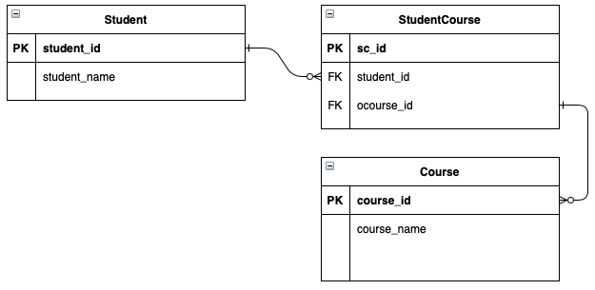

- Your DDL commands should be in following format:

-- SQL for Oracle | Mysql | PostgreSQL

Create table <table_name>
... columns...
... constraints...

Create table <table_name>
... columns...
... constraints...

Insert into <table_name> values ();
Insert into <table_name> values ();
Insert into <table_name> values ();
Insert into <table_name> values ();
Insert into <table_name> values ();

